India and the Indian Ocean: Between Potential and Predominance
Professor (Dr) Commander Bhushan Dewan (Retd.)

Byline:
The map has not changed since 1947. What must change with greater urgency is India's ability to translate geography into sustained maritime dominance.

The Traffic Jam We Inherited
The Indian Ocean continues to be described as a global trade artery. In my observation over the years, however, it has become a congested and increasingly contested strategic theatre. A visit to Visakhapatnam harbour in March 2024 brought this reality into sharp focus. Two Indian destroyers, a French frigate, a US oiler, and a Russian tanker were operating in proximity within roughly 800 metres of each other. Harbour pilots confirmed that such crowding has become routine since 2020. The steady flow of tankers from the Strait of Hormuz and container vessels from East Asia serves as a constant reminder of why these waters matter so deeply, as the alternative route around the Cape of Good Hope is simply not viable for most commercial shipping.

Having served in the Navy through decades of change, I have seen how India inherited this vital geography in 1947 yet devoted limited attention to its maritime potential for a long time. National focus remained on land borders, Partition, wars, and the urgent task of feeding a growing population. Consequently, the Navy was largely confined to coastal defence, receiving only about 12 percent of the defence budget until the 1990s. The 26/11 Mumbai attacks and the peak years of Somali piracy (2009–2012) acted as sobering reminders of our vulnerabilities. It was around this time that the expanding Chinese presence, often termed the “String of Pearls,” forced a serious reassessment of our maritime strategy.

China’s Playbook: Cranes, Not Carriers
In my view, China has followed a patient and calculated approach. Instead of relying primarily on large naval fleets in the initial phases, it has used economic tools, infrastructure development, and dual-use facilities to expand its maritime footprint gradually. The transfer of operational control of Gwadar port in 2013, the 99-year lease of Hambantota in Sri Lanka in 2017 after a debt default, and the establishment of a naval base in Djibouti in 2017 illustrate this pattern clearly. These facilities have enabled regular deployment of Chinese submarines, survey vessels, and support ships across the Indian Ocean. Discussions with a retired flag officer in early 2024 reinforced my own assessment. He described the strategy as “salami slicing with cranes” - a progressive sequence of debt, port development, and eventual military utility, including the possible emplacement of seabed sensor arrays near our critical sea lanes.

Our ORBAT vs Our Ambitions
Our doctrinal documents, especially the 2015 Maritime Security Strategy (and its subsequent updates), speak eloquently of blue-water ambitions and regional power projection. Yet, as someone who has followed naval development closely, I must note the persistent gap between these aspirations and actual capabilities. INS Vikramaditya still spends considerable time in refit due to recurring technical issues. INS Vikrant, commissioned in 2022, has shown encouraging performance, including in RIMPAC 2024, but continues to operate with a limited air wing and ageing MiG-29K fighters. The acquisition of new deck-based fighters remains unresolved.
The submarine arm presents a similar picture. Project 75 delivered its sixth boat, INS Vagsheer, in January 2025 after two decades of effort. Project 75I is still making slow progress. While the Arihant and Arighat SSBNs strengthen our strategic posture, the absence of nuclear-powered attack submarines (SSNs) remains a significant shortfall. Project 75 Alpha, cleared years ago, has yet to achieve substantial momentum. Expanding the surface fleet to the stated target of 175 warships by 2035 will require a marked acceleration in shipbuilding.

SAGAR Hits Reality: The Neighbourhood Test
The SAGAR vision, launched in 2015 and evolving into the broader MAHASAGAR framework, reflects a sincere attempt to combine security cooperation with regional development. However, experience in the neighbourhood has shown that goodwill and capacity-building assistance alone are often insufficient in the face of competing economic and political offers. The political shift in the Maldives in 2023, with its “India Out” campaign, led to the withdrawal of our aviation support personnel. This was soon followed by increased activity by Chinese survey vessels in the area. Similar dynamics have played out in Sri Lanka and elsewhere, highlighting the challenges of translating SAGAR into consistent strategic influence.
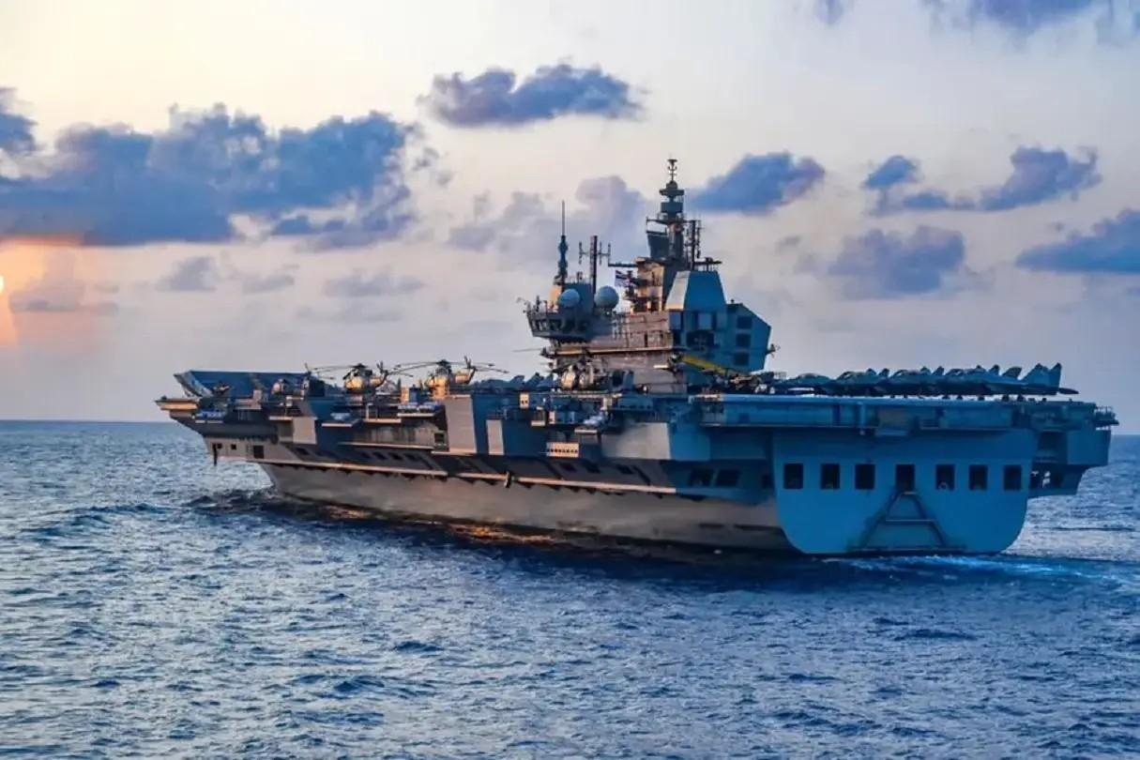INS Vikrant Source : wionews.com

The Shipyard Bottleneck
One of the most persistent constraints I have observed is our shipbuilding ecosystem. Public sector yards continue to grapple with delayed deliveries, mid-construction design changes, and reliance on imported systems. While capable private yards are available, strategic preferences often direct major orders to public sector shipyards. The third aircraft carrier, INS Vishal, has been under discussion for more than a decade, with key decisions on size and configuration still pending. This contrasts sharply with the rapid pace at which Chinese shipyards commission new combatants.

The Islands: India’s Unsinkable Aircraft Carriers
After years of relative neglect, the Andaman & Nicobar and Lakshadweep Islands are finally receiving the attention they deserve. These scattered territories, though small in land area, account for nearly 30 percent of India’s Exclusive Economic Zone and offer immense strategic depth. Among these, the Great Nicobar Island Development Project stands out as the most ambitious and strategically significant initiative. Centred on the proposed International Container Transshipment Port (ICTP) at Galathea Bay, this ₹72,000–90,000+ crore mega-project (with some estimates reaching ₹1 lakh crore) aims to transform the southernmost of the Andaman and Nicobar chain into a major logistics, economic, and dual-use hub.
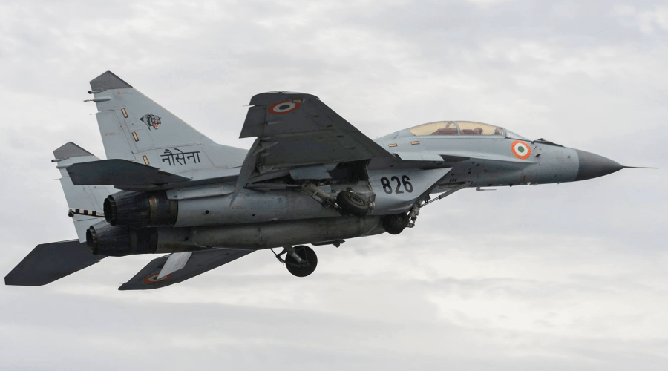MiG-29K
Source : defence.in

An Exploration of the Great Nicobar Transshipment Port
Great Nicobar Island lies approximately 40–90 nautical miles from the Strait of Malacca, one of the world’s busiest and most critical chokepoints, handling a substantial share of global trade and a critical proportion of China’s energy imports. This proximity gives Galathea Bay a natural strategic advantage that few ports in the region can match. The project, conceived by NITI Aayog and implemented through the Andaman and Nicobar Islands Integrated Development Corporation (ANIIDC), encompasses four integrated components:
- Galathea Bay International Container Transshipment Terminal (ICTT): Designed for an ultimate capacity of 16–16.2 million TEUs (Twenty-foot Equivalent Units). Phase 1 targets 4 million TEUs by 2028 with an investment of around ₹18,000 crore (part of the first two phases at ~₹44,000 crore). The port benefits from natural water depths exceeding 20 metres, eliminating much of the dredging required elsewhere, and will feature automated, green logistics systems.
- Dual-use Civil-Military Airport: Capable of handling large aircraft, including P-8I maritime patrol planes, with potential for forward air operations.
- Power Plant: Approximately 450 MW, combining gas and solar sources to support the port and township.
- Integrated Township: Planned to eventually house up to 650,000 residents, supporting logistics, tourism, and defence personnel.
As of mid-2026, the project has received significant momentum. The National Green Tribunal (NGT) upheld the environmental clearances in early 2026, citing the project’s strategic national
importance. The port has been notified as India’s 13th major port. Detailed Project Reports (DPRs) have been finalised, with PPP structures advancing under a joint venture model, where an Indian entity holds majority stake (51–55%) and select public sector ports hold the balance, explicitly excluding foreign operators for strategic reasons.
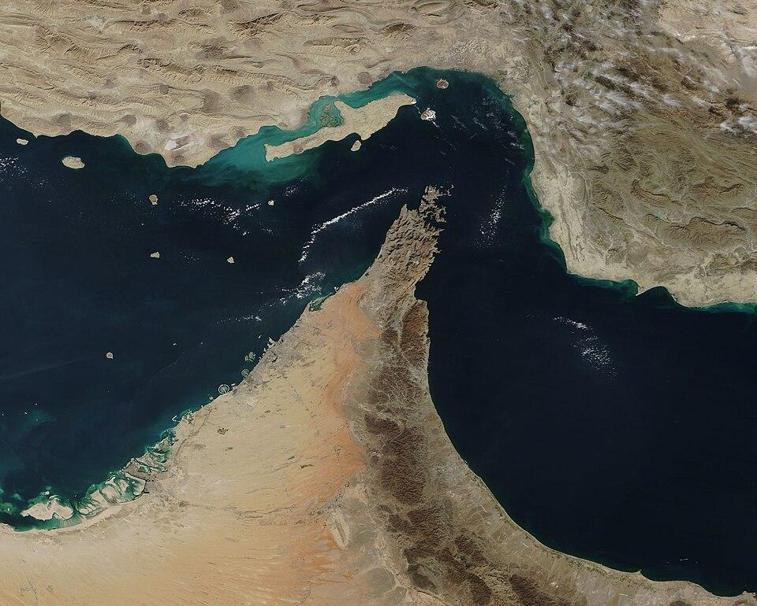Strait of Hormuz, waterway between the Persian Gulf and the Gulf of Omanccccccc

Strategic Significance
From a naval perspective, Great Nicobar functions as a forward operating base and “unsinkable aircraft carrier.” It enables persistent surveillance over the Six Degree and Ten Degree Channels, strengthens monitoring of Malacca Strait approaches, and provides a logistics node for sustained blue-water operations. In a contingency, it could support carrier groups, submarines, and air assets far from the mainland, reducing vulnerability to anti-access strategies.

Economically, the port addresses India’s heavy dependence on foreign transshipment hubs (Singapore, Colombo, Klang), which currently handle a large portion of Indian cargo. Capturing even a fraction of the regional transshipment traffic could generate substantial revenue while boosting the blue economy through ship repair, bunkering, and ancillary industries. Recent seismic surveys south of Indira Point have also hinted at promising hydrocarbon potential, which, if realised, would add another layer of asset protection requirements for the Navy.

Challenges
The project is not without difficulties. It involves diversion of approximately 130 sq km of forest land, affecting biodiversity hotspots home to endemic species such as the Nicobar megapode, leatherback turtles (for which Galathea Bay is a critical nesting site), and the Shompen and Nicobarese indigenous communities. Environmental concerns include coral reefs, mangroves (natural tsunami barriers), and marine ecosystems. The NGT clearance mandates safeguards, but implementation will require rigorous monitoring.

The Verdict: Map vs Reality
India enjoys an enviable geographic position, astride 11 of the world’s 17 major maritime chokepoints. A very large share of global energy and container traffic, including roughly eighty percent of China’s oil imports, passes through waters close to our shores. Yet, after decades of service and reflection, I believe we are still in transition. Progress on indigenous carriers, island development, and shipbuilding is visible, but current force levels, acquisition timelines, and industrial capacity suggest that we remain some years away from becoming the predominant naval power in the Indian Ocean. The map has not changed since 1947. What must change with greater urgency is our ability to translate this geography into sustained maritime dominance. The strategic competition is intensifying, and the window for decisive action is narrowing.

Strategic Recommendations

To accelerate India’s blue-water transition, the following measures merit urgent consideration:

- Prioritise SSN Development: Fast-track Project 75 Alpha with parallel indigenous and collaborative tracks (technology transfer under strict safeguards) to achieve the first SSN by early 2030s. Nuclear attack submarines are indispensable for tracking adversary assets in the IOR.
- Accelerate Shipbuilding Reforms: Introduce performance-linked incentives for yards, allow greater private sector participation with technology mandates, and standardise designs to move away from “every ship is a prototype” syndrome. Target at least 4–5 major combatants annually.
- Fully Leverage Great Nicobar: Ensure the Galathea Bay project integrates seamlessly with naval requirements. Allocate dedicated defence berths, hardened infrastructure for munitions and fuel, and P-8I/MH-60R basing. Complete the township and airport in synchronised phases to avoid capability gaps. 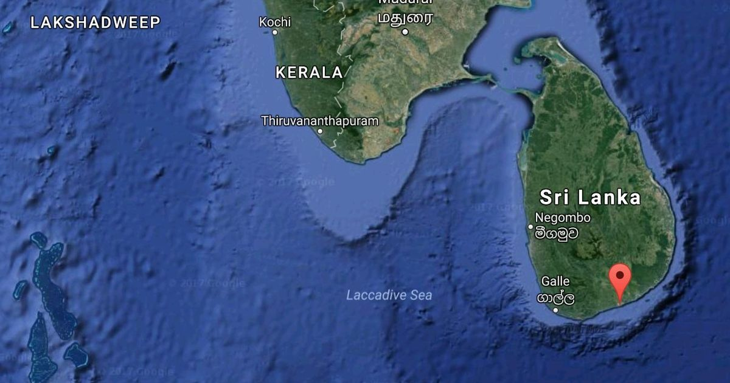
Hambantota port
Source : amp.scroll.in

- Enhance Neighbourhood Engagement: Move beyond infrastructure gifting under SAGAR to structured security pacts, joint EEZ patrols, and intelligence-sharing mechanisms. Economic incentives must be backed by credible security guarantees.
- Carrier and Air Wing Modernisation: Finalise the next carrier-based fighter acquisition (Rafale-M or equivalent) within the next 12–18 months and commit to INS Vishal as a CATOBAR platform for long-term power projection.
- Invest in Unmanned and Multi-Domain Capabilities: Develop a robust drone and autonomous underwater vehicle (AUV) ecosystem for persistent surveillance around the islands and chokepoints.
- Sustained Budgetary Support: Raise the Navy’s share of defence capital expenditure to at least 25–28% over the next decade, ring-fencing funds for island infrastructure and submarine projects.
- Environmental and Social Integration: For Great Nicobar and similar projects, adopt international best practices in mitigation - real-time biodiversity monitoring, community relocation with consent and benefits, and green port technologies - to build long-term legitimacy and resilience.
Implementing these recommendations with consistency and political resolve would enable India not only to counter external challenges but to emerge as the natural net security provider and predominant naval power in the Indian Ocean Region by 2040.

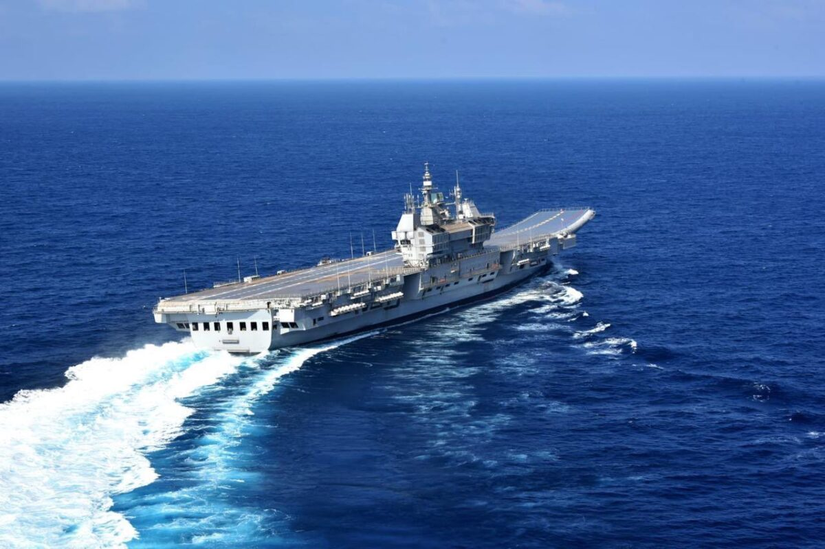
INS Vikrant: The First Indigenous Aircraft Carrier
Source : indiandefencereview.com

